16.51: For the flute, the fundamental frequency is
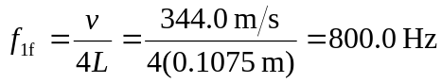
For the flute and string to be in resonance,
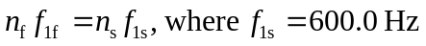is the fundamental frequency for the string.
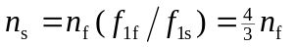
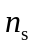 is an integer when 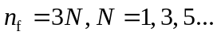(the flute has only odd harmonics)
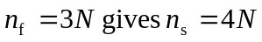
Flute harmonic 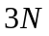resonates with string harmonic 